**ARC-GIS**

**EXCERCISE: 4**



**BY – AMANUEL LEGESSE SOFTWARE ENG. EXT**

**ID – ATE/3628/11**

**VISUALIZING DATA IN**

**ARCGIS**

**Creating a map Layout using ArcMap**

* Step 1 Start ArcMap and open a map document:
* 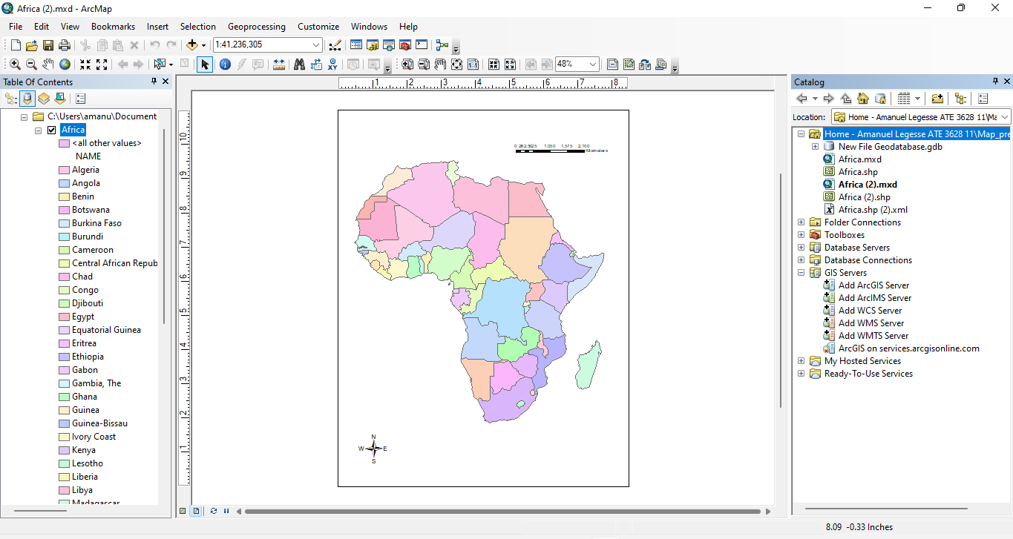 Had to navigate to the folder and select Africa.shp to preview the map.
* Step 2 Change the size of the data frame in the layout
* The scale of the data frame was changed to 1:60,000,000.

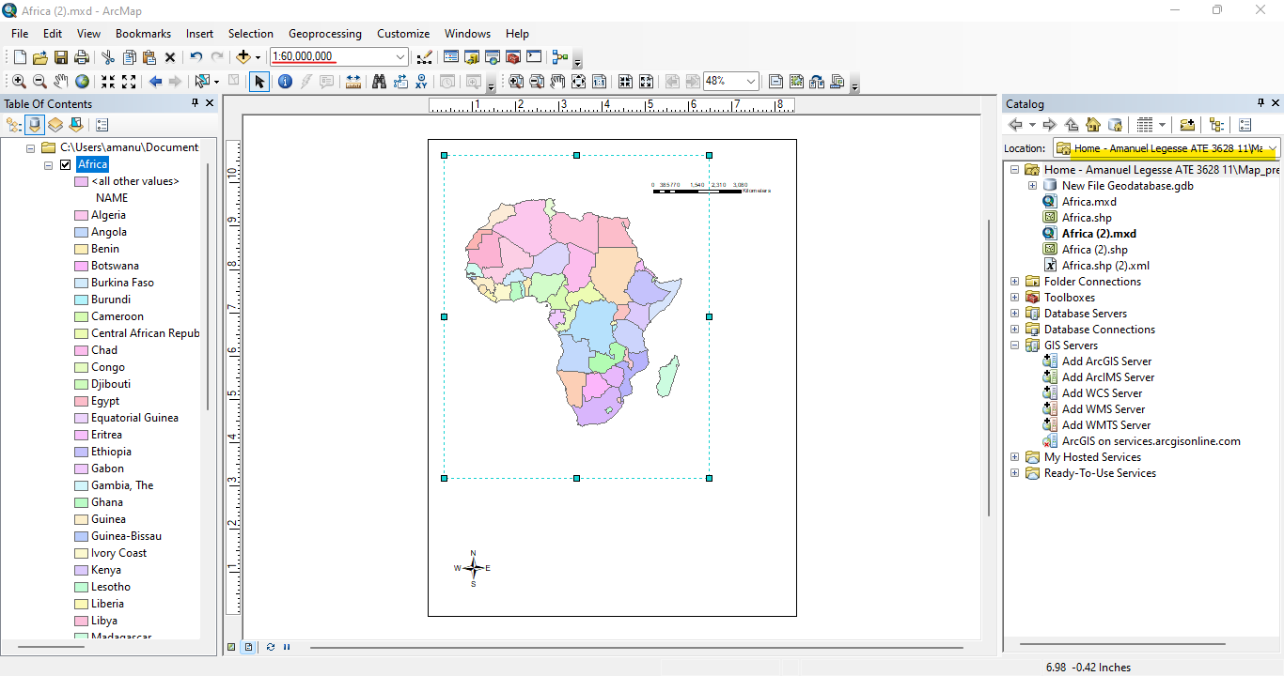

* Step 3 Create a map inset
* When creating a copy of the data frame its seen that a new data frame is added to the table of contents

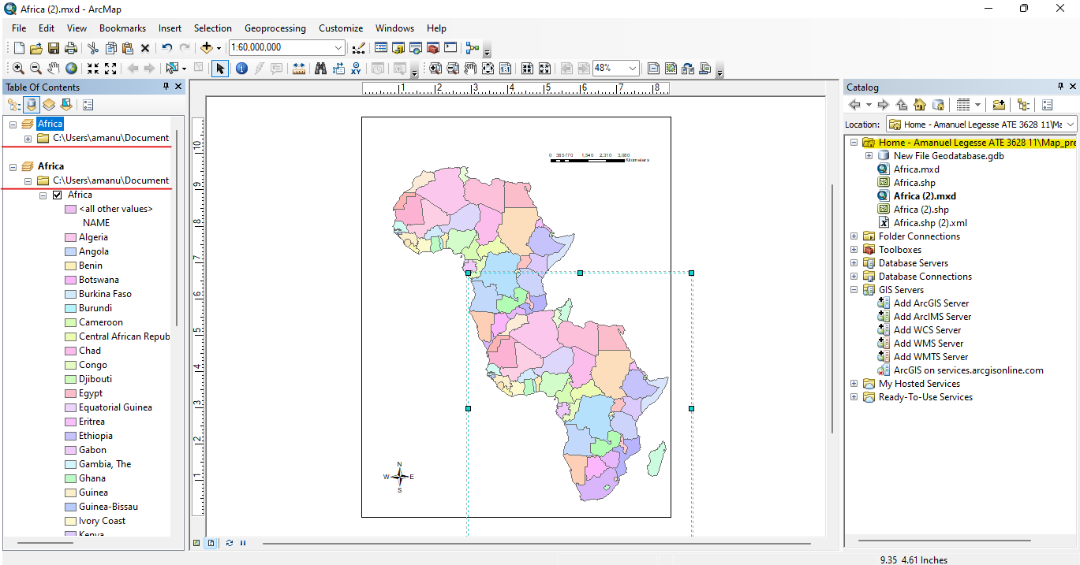

* The value of the width and height was changed to 40%

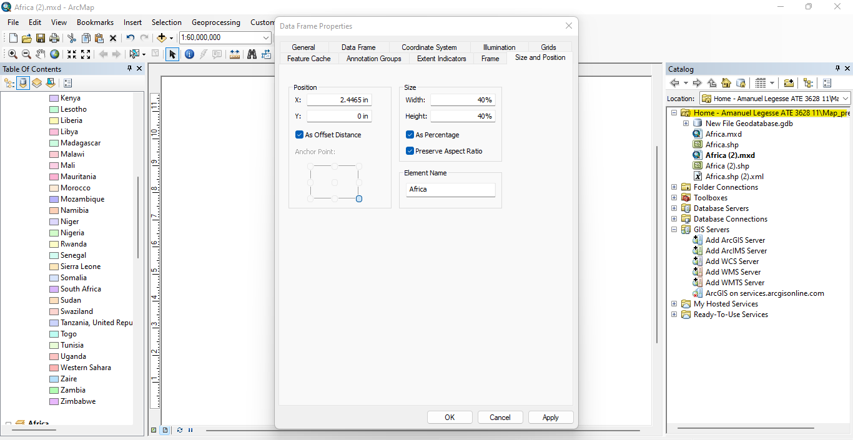

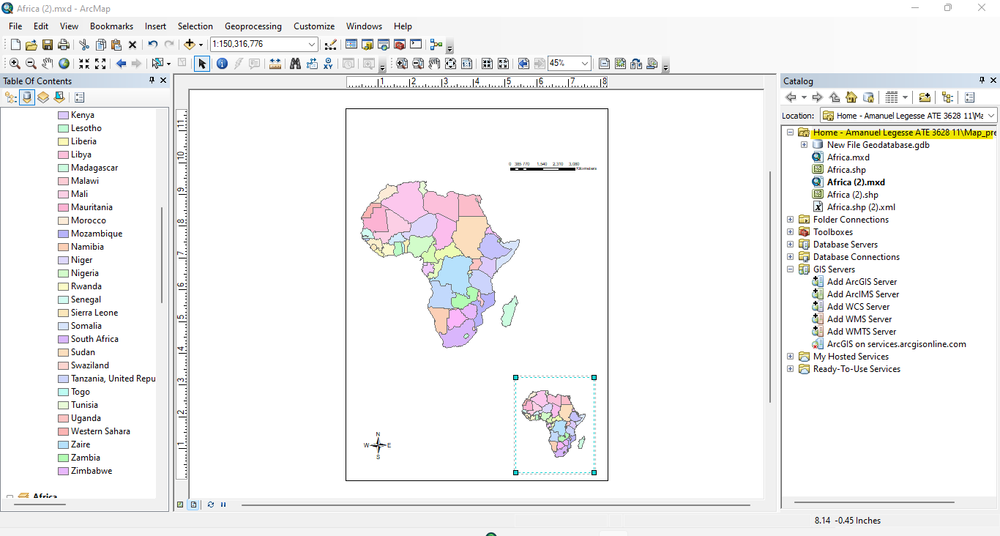

* Step 4 Symbolize the map inset
* Quantities of the Graduated colors Fields area POP2000 was chosen and the Color was changed to yellow to red shade ramp.

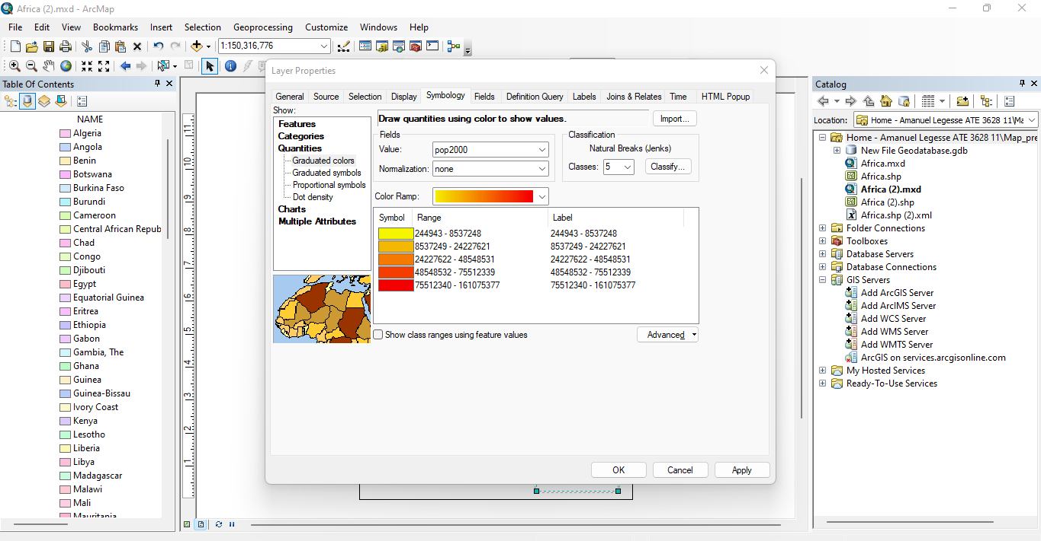

* The name of the new data frame is changed to Africa population.

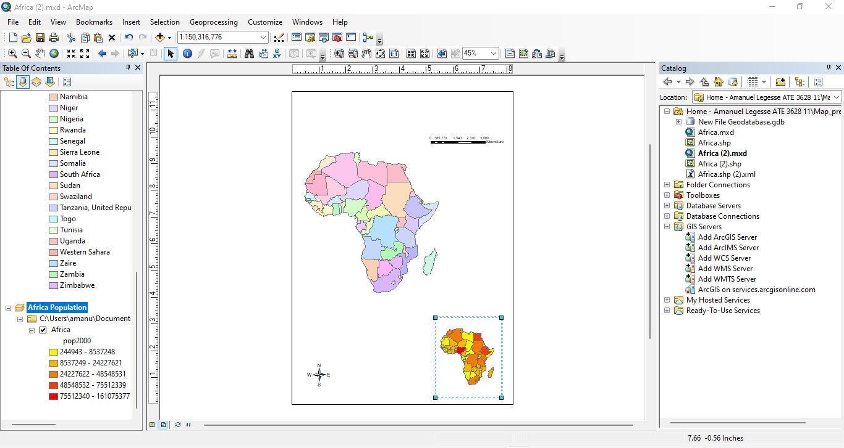

* Step 5 Refine the appearance of the data frames
* Changed the frame boarder and colors.

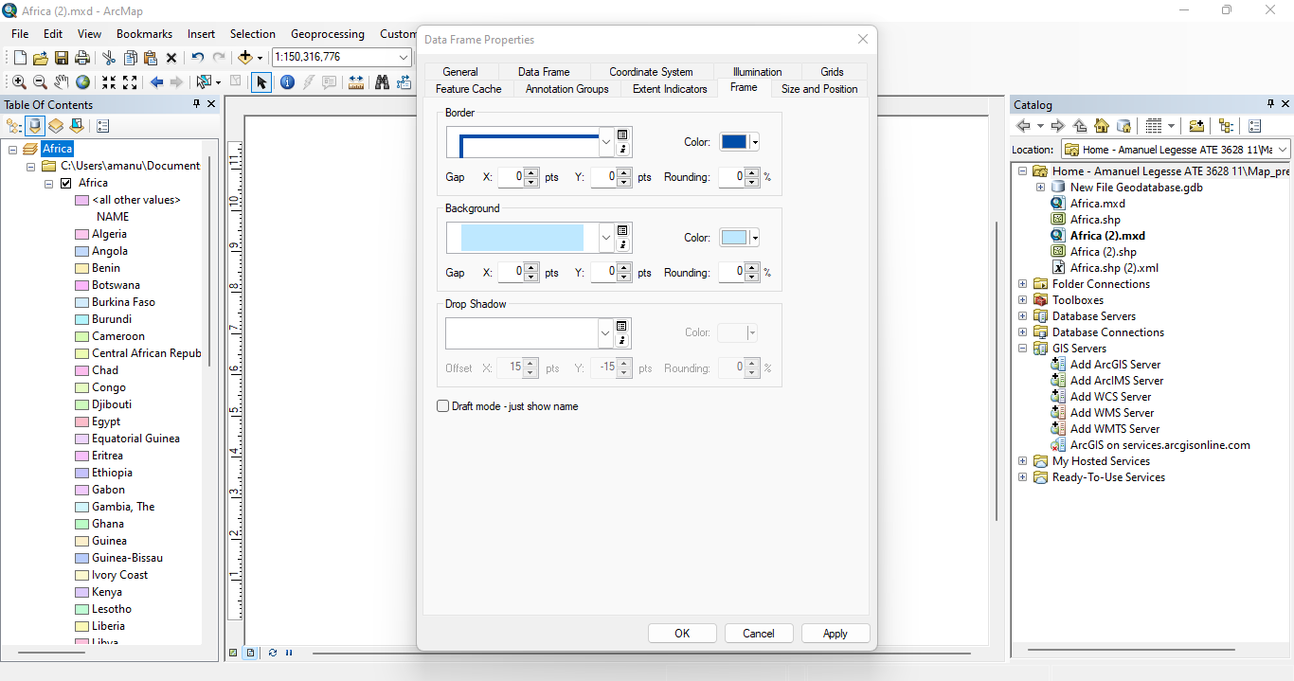

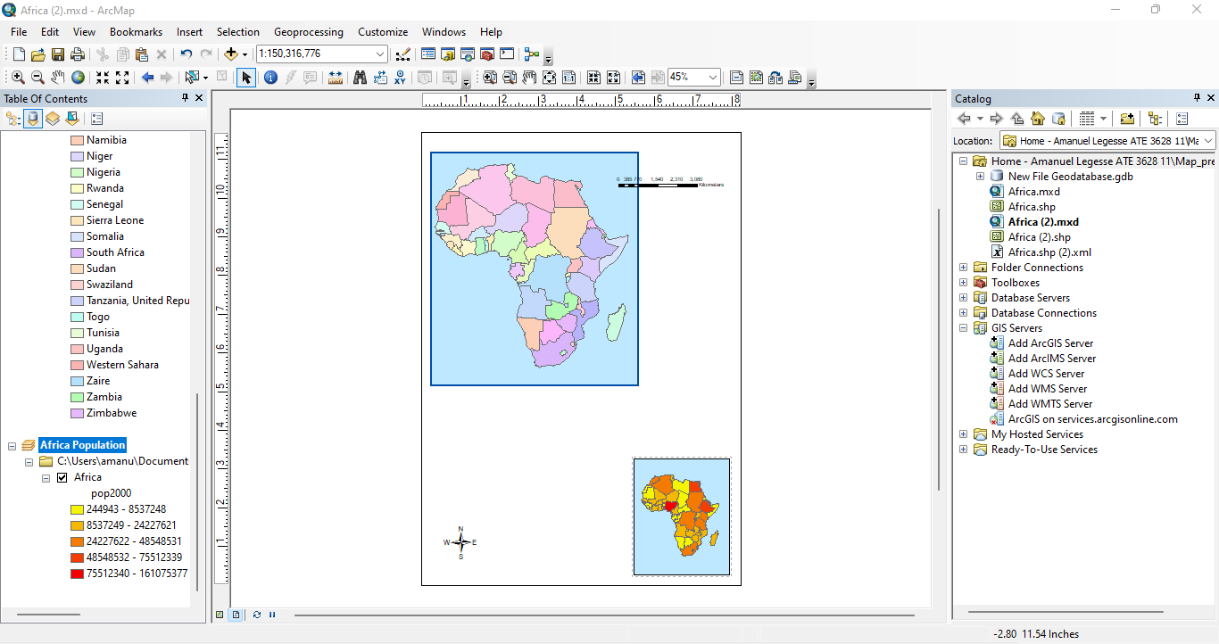

* Step 6 Add a title to the layout
* The title is now changed to AFRICA.

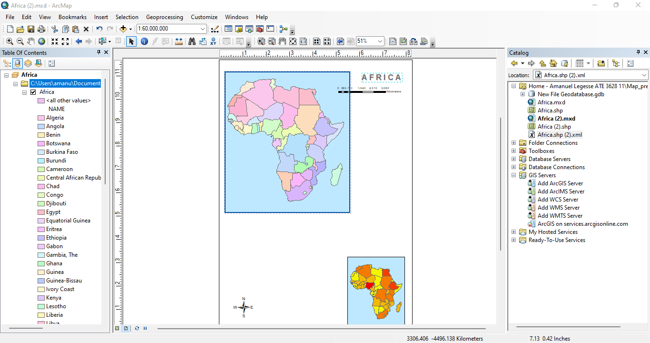

* Step 7 Add a legend to the layout
* The following legend has been added to the data frame using the size and position to be placed next to the Africa data frame.

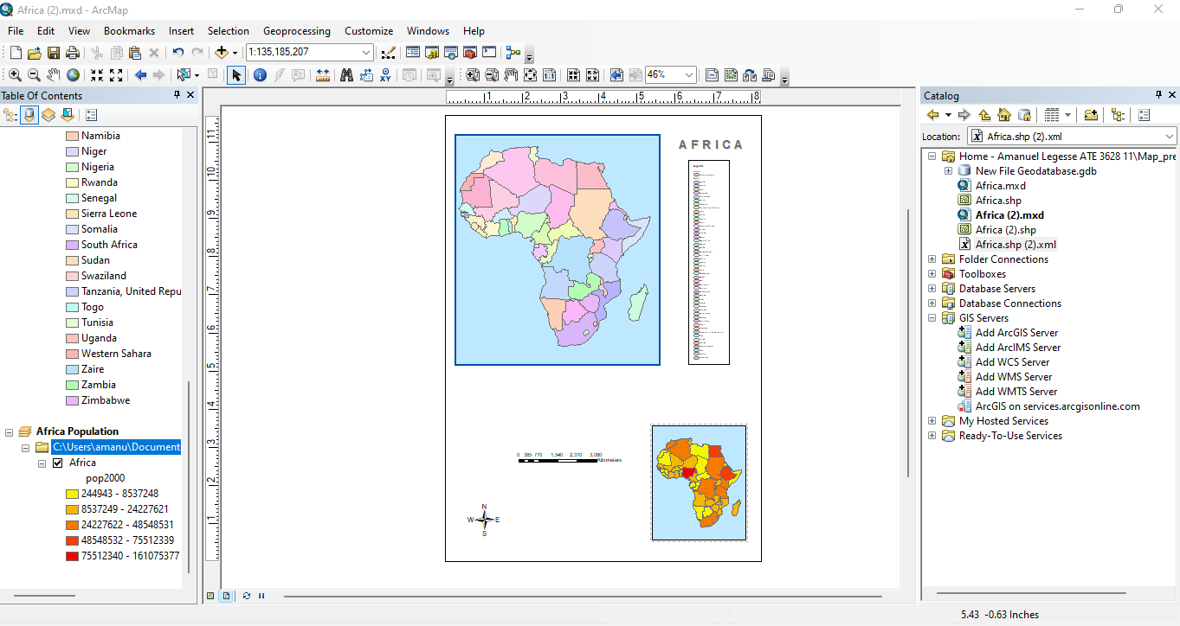

* Unchecking the show button hides the legends title.

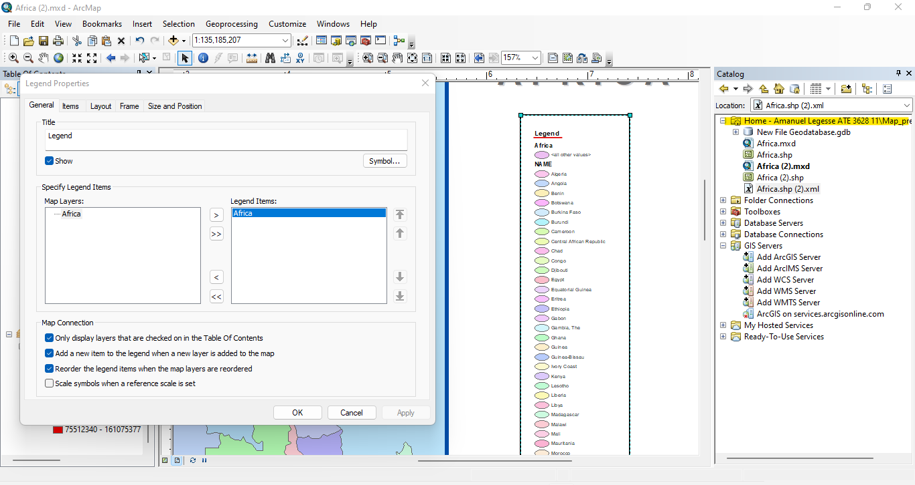

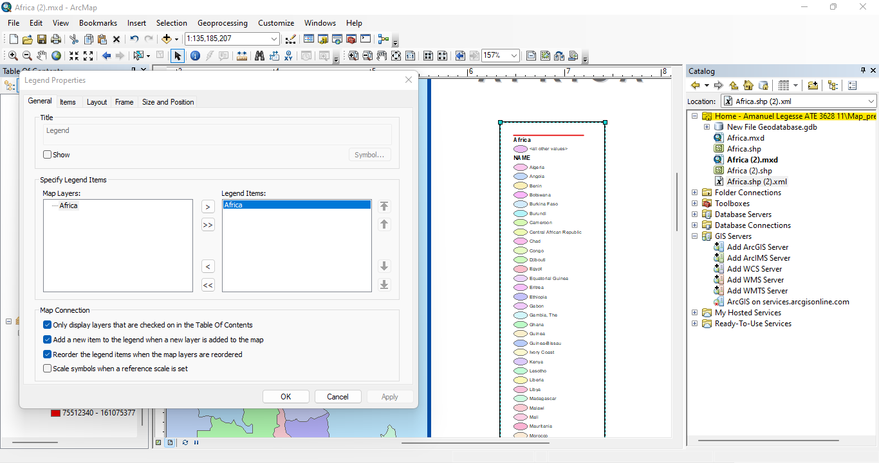

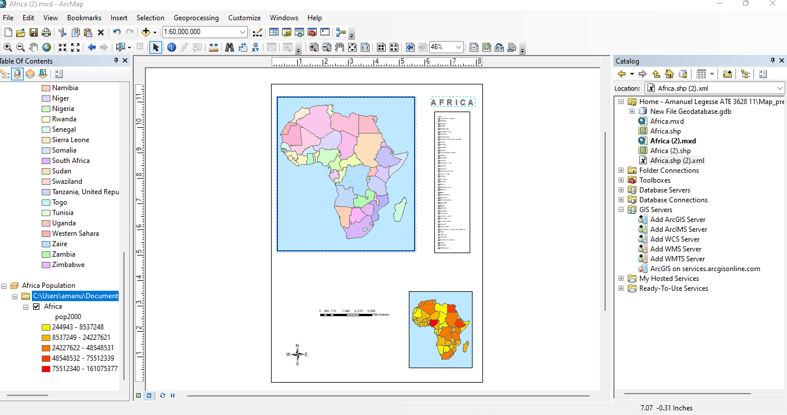

* Step 8 Add a legend for the map inset
* A legend is created with title 2000 population and resized to fit inside the Africa population data frame.

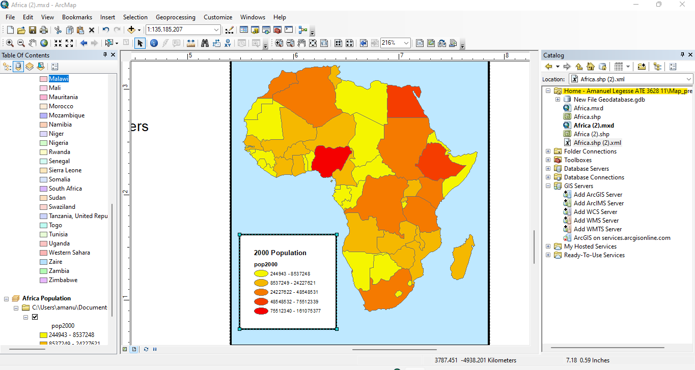

* Changed to color ramp to red to green then flipped it then modified the range values.

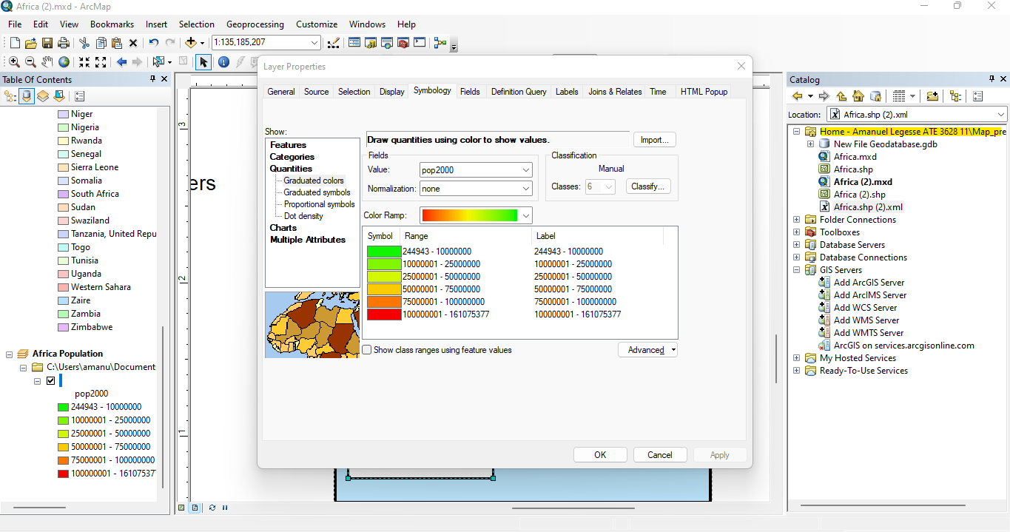

* Step 9 Position the north arrow

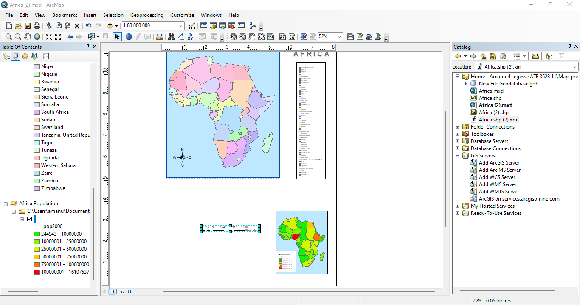

* Step 10 Modify the scale bar and add scale text.

Modified scale km to 1000.

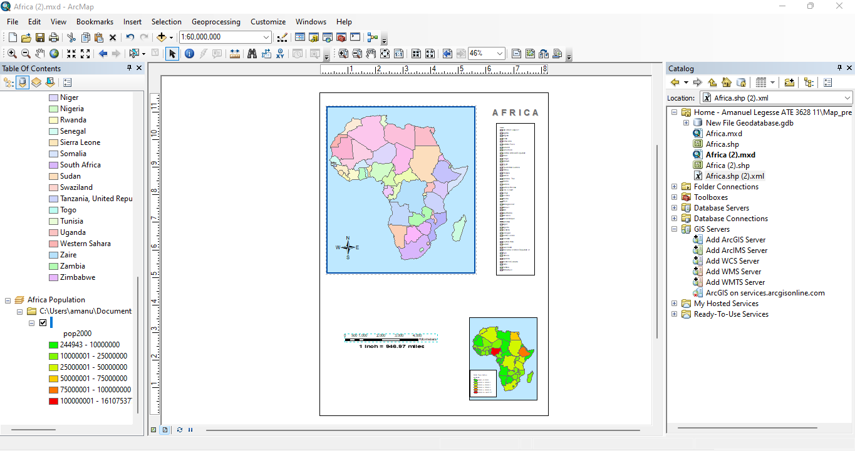

* Step 11 Add a border and background color to your layout
* Added a back ground layout of color sand by inserting Neatline.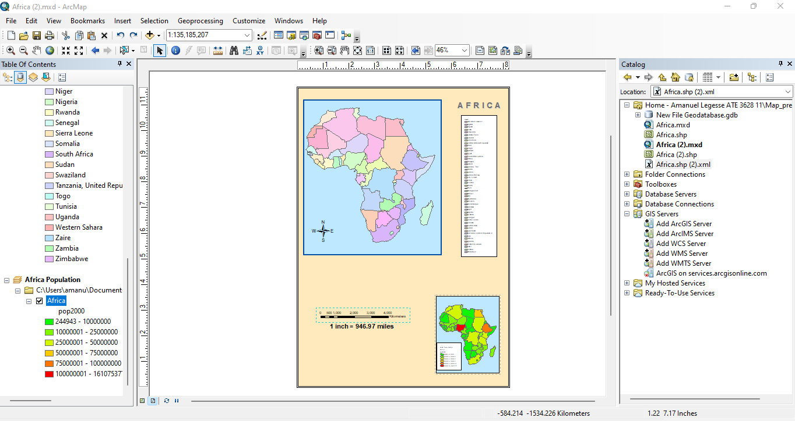
* Step 12 Save your map

